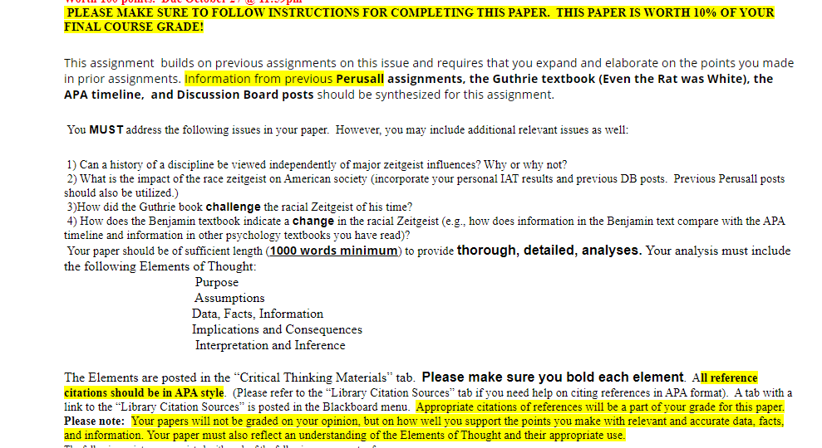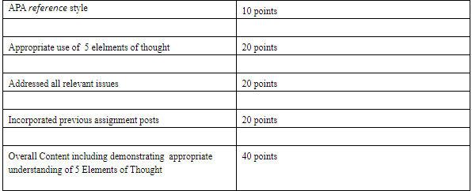
View the APA slide show on the Women in Psychology timeline at https://www.apa.org/pi/women/iampsyched/timeline.aspx
https://www.apa.org/monitor/nov01/american

A Brief History of Modern Psychology 2nd Edition by Ludy Benjamin

